CST 150 – Web Design and Development I

Website Final Project

The purpose of this project is to design a 3-page website using the concepts discussed throughout the semester. Any topic can be chosen for this website project. Sample topics include:

- Website about a famous person or place
- Biographical website about yourself
- Website about an organization you are a member of

The website must have a minimum of 3 pages. The website must contain the following features:

- External CSS linked to by all pages
- Common Interactive Navigation Bar on all pages
- Footer on all pages
- Image Gallery
- At least two unique page layouts

Grading Criteria

Your website will be graded based on the following criteria:

Functionality | 75% | All elements present, Links work properly, CSS rules defined clearly
Design | 25% | Web site has attractive layout, styles (background, fonts, colors, etc.) are consistent throughout site, html tags are used appropriately to structure content

Extra Credit (10%): Extra credit will be awarded for incorporating the following:
- Image Map
- Web Fonts
- Audio/Video
- Other enhancements …

Project Steps

1. Wireframe Sketches / Sitemap
Create a Wireframe Sketch in paper/pencil that describes what each page in your website will look like. The wireframe sketch is meant to broadly show all of the items that are included on particular page.

You must complete two wireframe sketches for each unique page layout. One wireframe sketch should be for the desktop version of the page. A second wireframe sketch should be for the mobile version.

Additionally, create a Sitemap that diagrams the organization of web pages in your project.
See Figures below.
Due date: 11/3/14

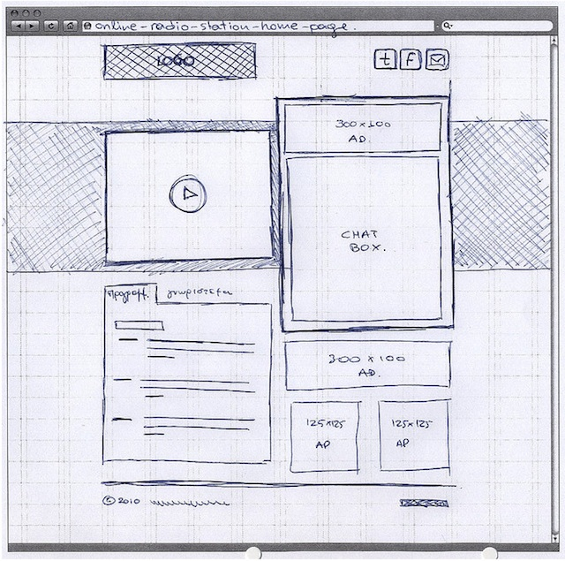
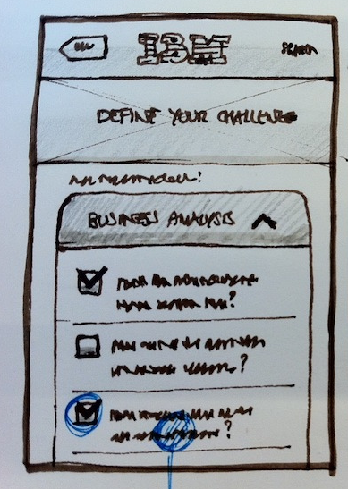

Figure2. Wireframe Sketch (Mobile)

Figure1. Wireframe Sketch (Desktop)

Home
Gallery
Contact Us
Services
Figure3. Sitemap

2. Design HTML and CSS
Based off the Desktop wireframe sketch, create the HTML and CSS documents for each page in your website. Identify the major structural html elements (div, nav, header, footer, section, aside ) that each page will contain. Create the CSS rules that position the structural elements throughout the page. Create CSS rules that format the appearance (background, border, color, etc.) of the elements on the page.

You do not have to code the mobile version of the page for this project.

Due date: 11/17/14

3. Embed Multimedia
Insert appropriate images, audio and video elements into your pages. Use image editing software as necessary to manipulate images.
Due date: 12/1/14

Project Submission

You must submit the following documents:
- Wireframe sketch of each unique page layout on your site
- Sitemap
- HTML and supporting documents (images, audio, video, css, js)

Your final projects must be submitted to the instructor as follows:
- Upload your final project to your web folder on bigmanhosts.com.

Due Date

The final project is due on day of final exam, Wednesday December 17th.

Project Presentations

Each student must give a brief 5-10 minute presentation of their web page to the class. Project presentations are mandatory.

